

*Effortless, personalized study groups tailored to your schedule, preferences, and learning styles*

Final Report

CS147 Fall 2024

AI in the Classroom

Alexander Yue | Evan Hsu | Diego Valdez | Ecem Yilmazhaliloglu

**Table of Contents**

Page

| Project Name & Value Proposition | 2 |
| --- | --- |
| Team Member Names and Roles | 2 |
| Problem & Solution Overview | 3 |
| Needfinding | 4 |
| POVs & Experience Prototypes | 7 |
| Design Evolution |  |
| Final Prototype Implementation |  |
| Reflection & Next Steps |  |

**Project Name & Value Proposition**

**Project Name**

LockedIn

**Value Proposition**

Effortless, personalized study groups tailored to your schedule, preferences, and learning styles

**Team Member Names and Roles**

|  | *Sophomore, Physics*  Developer, Product Manager |
| --- | --- |

|  | *Coterm, Computer Science HCI*  Developer, UX/UI Designer |
| --- | --- |

|  | *Coterm, Computer Science HCI*  Developer, UX/UI Designer |
| --- | --- |

|  | *Senior, Computer Science*  Developer, Product Designer |
| --- | --- |

**Problem & Solution Overview**

**Problem Statement**

After conducting multiple needfinding interviews, our team found that students often face challenges when trying to connect with peers to collaborate. Social anxiety, differing schedules, and varying study habits can make it difficult for students to find and engage with others. In addition, organizing and managing class materials can be overwhelming, as it is common for students to manage multiple subjects, assignments, and deadlines.

**Our Solution**

Our app addresses these challenges by offering an intuitive platform that facilitates collaboration and classwork management. Students can upload their class materials and have our AI system organize them into clear, actionable tasks. These tasks can be manually customized and efficiently updated to suit user preferences. Additionally, our matching feature promotes effective and supportive study collaborations. By taking a study profile survey, students are matched with peers who have similar schedules and study habits. Our app also enables students to host public study sessions within their classes, promoting group study and collaboration.

**Needfinding**

**The Interviews**

Our target domain was college students, and we conducted a total of 6 interviews across two rounds of needfinding. For interviewee sourcing, each team member tapped into their personal networks,including friends of friends. Some interviews required traveling off campus, with one trip to UC Berkeley. We offered compensation as incentive for interviewees who were less familiar with us. Each interview was conducted by two team members- one acting as the interviewer and the other as the notetaker.

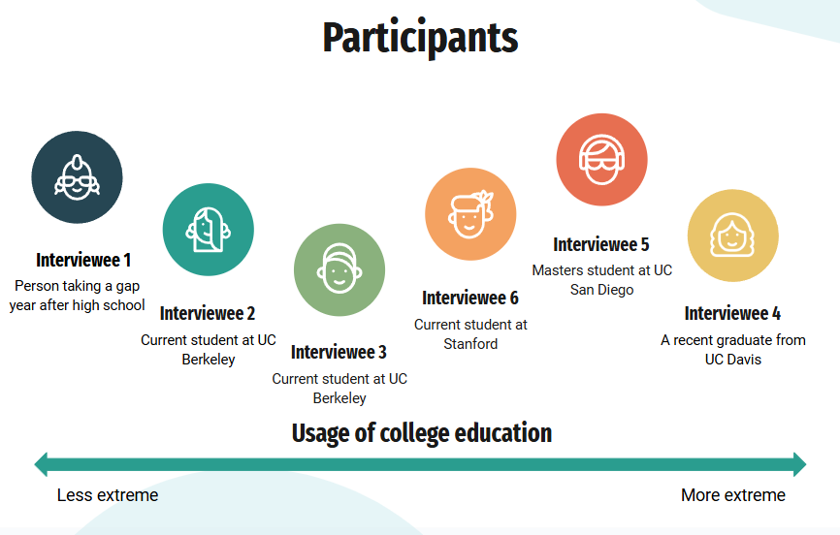

Figure 1 - Distribution of interviewees on a scale from less to more extreme based on their usage of college education

Our questioning process focused on three key areas:

1. **Learn about their identity** - We asked questions such as “What do you study” and “What are your academic goals and interests?” to better understand the backgrounds of each interviewee.
2. **Discover pain points** - We asked questions such as “What difficulties do you encounter when studying?” and “How do you currently manage your schoolwork?” to explore the challenges that they might face.
3. **Explore their behaviors** - We asked questions such as “What tools do you use to stay on top of your assignments?” and “In the case where you experienced difficulty in collaborating with others, what did you do instead?” to understand their current approach to addressing their pain points.

Interviewee details are listed below:

1. Gap year student, 2 years of public high school, 2 years of IB (extreme user)
2. Sophomore at UC Berkeley, public health major, pre-med, researcher at UCSF
3. Sophomore at UC Berkeley, public health major, pre-med, works in the Essig Museum of Entomology
4. Recent graduate from UC Davis, BS in Environmental Science and Management, minor in Environmental Policy Analysis and Planning
5. Masters student at UCSD, electrical engineering major, lives off-campus
6. Masters student in Community Health and Prevention Research at Stanford, pre-med

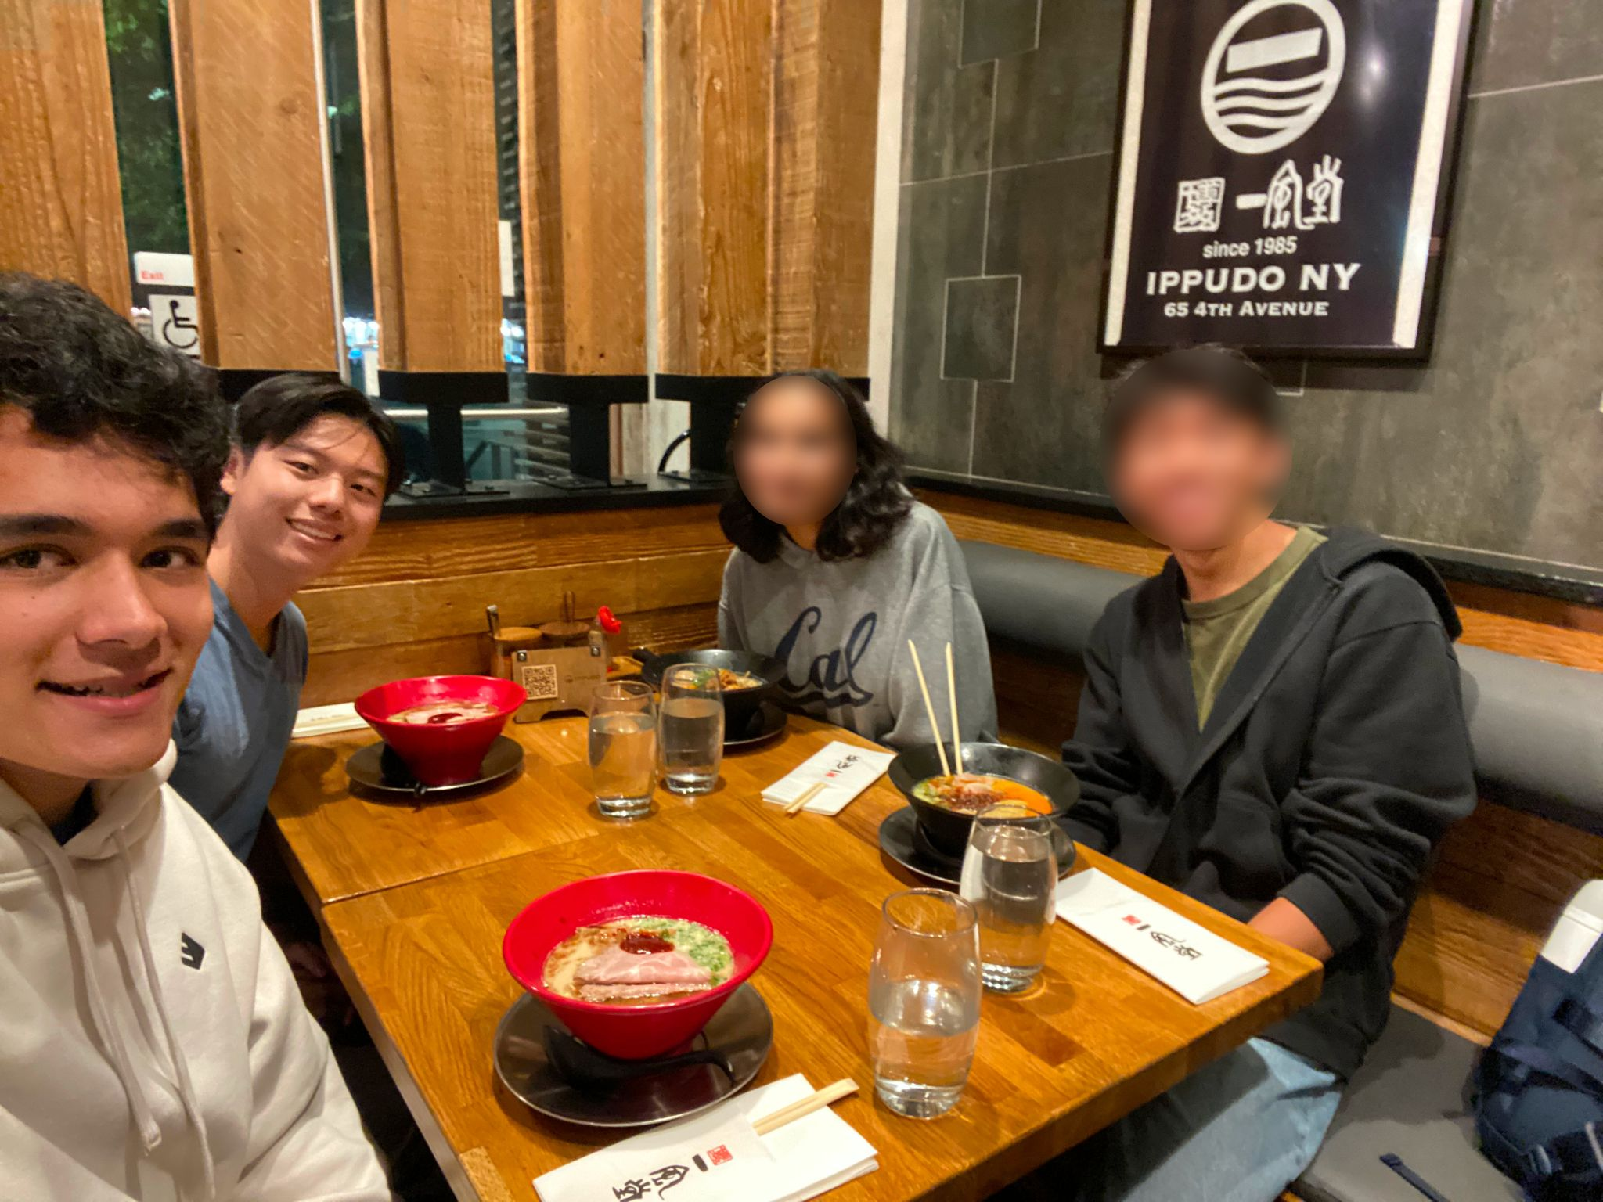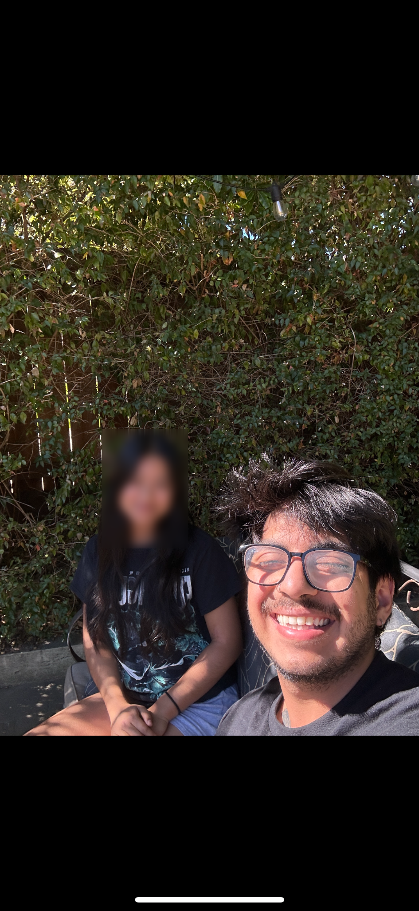

Figure 2 - Selected photos from needfinding interviews 2,3, and 4

**Result Synthesis**

Our needfinding interviews provided critical insights into the key challenges faced by students. To analyze the data from our interviews, we created an empathy map for each interviewee, writing notes on what each person says, thinks, does, and feels. We also compiled important quotes from each interview to highlight key themes and perspectives.

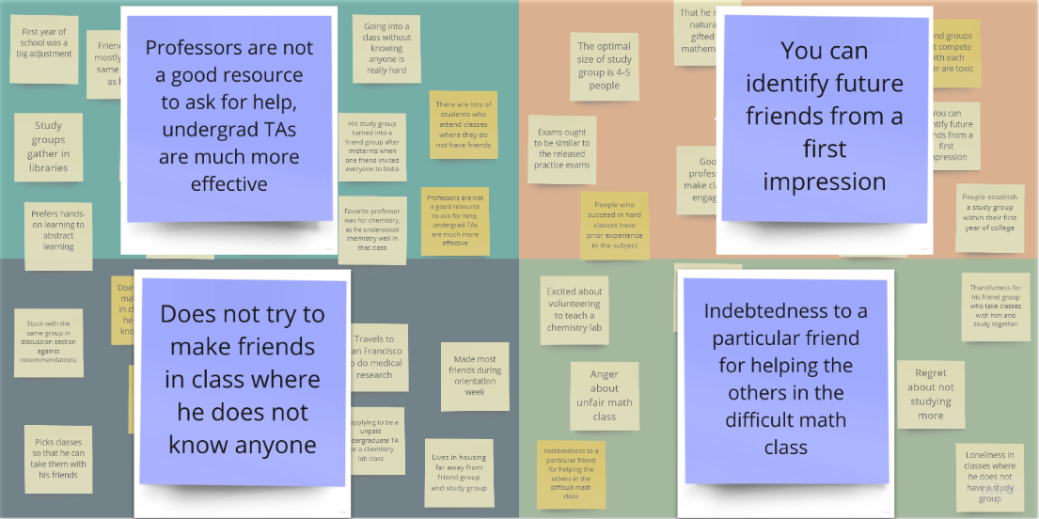

Figure 3 - An empathy map from interview 3

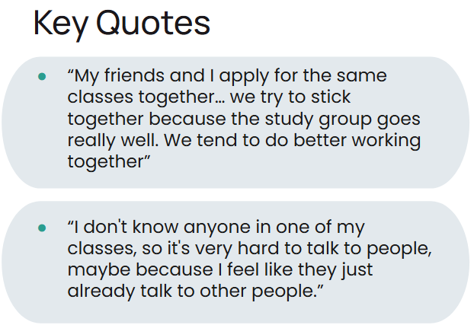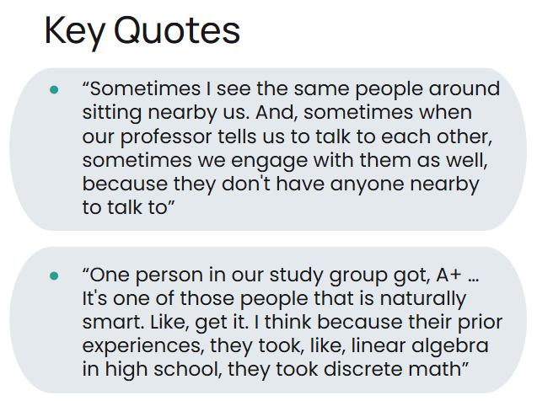

Figure 4 - Selected key quotes from our interviews

Following our interviews, we arrived at these takeaways:

* Connecting with other students to collaborate or share resources can be challenging
* There are personal barriers to peer collaboration
* Engagement is key to learning

**POVs & Experience Prototypes**

In our next steps, we reviewed the empathy maps from each interview and selected the three most valuable interviews to analyze further. We decided to craft a POV statement for interviewees 1, 3, and 4. These statements outline who our interviewees are and allow us to establish topics for brainstorming. For each of our POVs, we generated 10 How Might We (HMW) statements to guide the development of solutions.

a. Your final 1-3 POV statements b. A sampling of the HMWs that stemmed from each POV c. Top 3 solutions from brainstorming d. Brief description of each experience prototype: i. The assumption being tested ii. Key aspects of the prototype setup iii. What worked/didn't work, implications

**Final POVs and HMW Samples**

**Interviewee #1**

Details:

* gap year student
* 2 years of public high school
* 2 years of IB
* Our extreme user

POV

*We met*

“Jane,” a highschool graduate taking a **gap year** to reapply to college, who feels she hasn’t been supported enough during the college applications process.

*We were surprised to notice*

She believes guidance from others would have helped her with college applications, but **doesn’t know how to reach out to** others for feedback.

*We wonder if this means*

The **anxiety** of opening up to other students about her application is causing her to fall behind

*It would be game-changing if*

Students had **assistance** in sharing their application experiences and tips.

We brainstormed HMW statements together in a 5 minute time period for interviewee #1

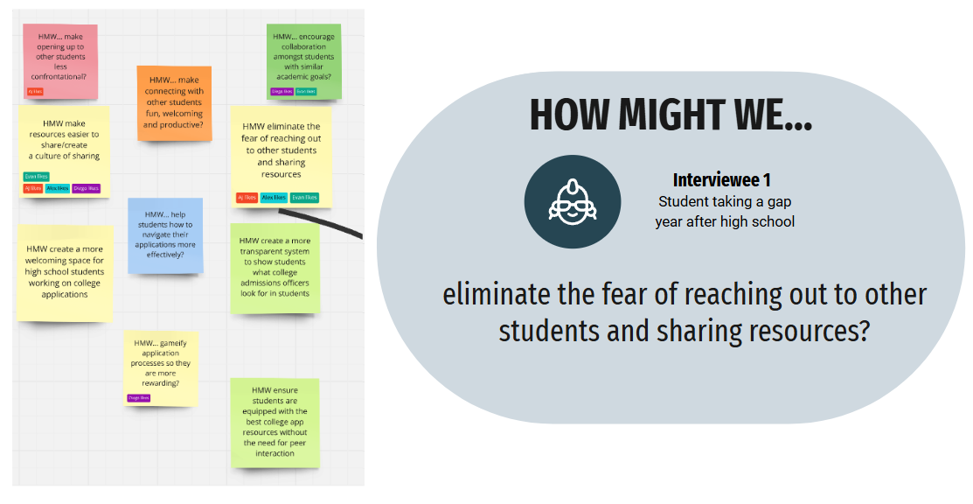

Figure 5 - HMWs for Interview #1 and a highlight of our favorite HMW

**Interviewee #3**

Details:

* Sophomore at UC Berkeley
* Public health major
* Pre-med
* Works in the Essig Museum of Entomology

POV

*We met*

“Gavin,” a hardworking pre-med student at UC Berkeley who feels he has **less prior academic experience** than many others.

*We were surprised to notice*

The **awkwardness** of meeting new people is preventing him from reaching his **academic goals**.

*We wonder if this means*

The **anxiety** of opening up to other students about her application is causing her to fall behind

*It would be game-changing if*

Students felt **comfortable** working with each other in every class.

We brainstormed HMW statements together in a 5 minute time period for interviewee #3

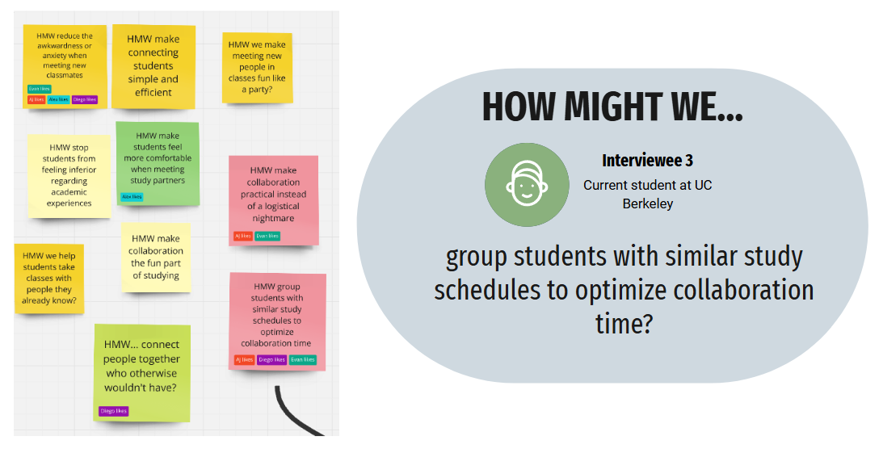

Figure 6 - HMWs for Interview #3 and a highlight of our favorite HMW

**Interviewee #4**

Details:

* Recent graduate from UC Davis
* BS in Environmental Science and Management
* Minor in Environmental Policy Analysis and Planning

POV

*We met*

"Sofia," a recent Environmental Science **graduate** from UC Davis, who often felt **overwhelmed** by the pressures of navigating both her academic and career journey.

*We were surprised to notice*

Despite expressing difficulty in **finding resources** for classes and internships, Sofia was able to name a few that she successfully utilized.

*We wonder if this means*

The issue may not be an overall lack of resources, but that the resources don’t translate into **clear, personalized support** for students.

*It would be game-changing if*

Students could **confidently** navigate their academic & career paths utilizing personalized available resources.

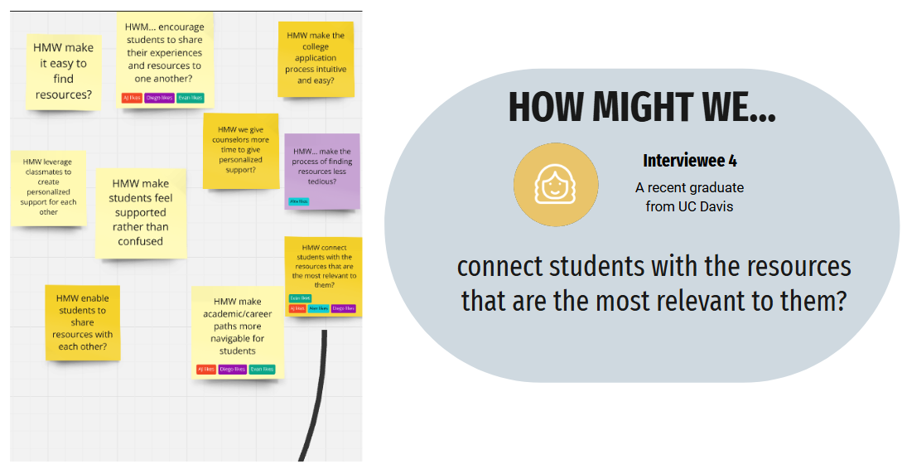

Figure 7 - HMWs for Interview #4 and a highlight of our favorite HMW

**Top 3 Solutions from Brainstorming**

After brainstorming our HMWs, we formulated a solution for each HMW statement that we highlighted from each interview.

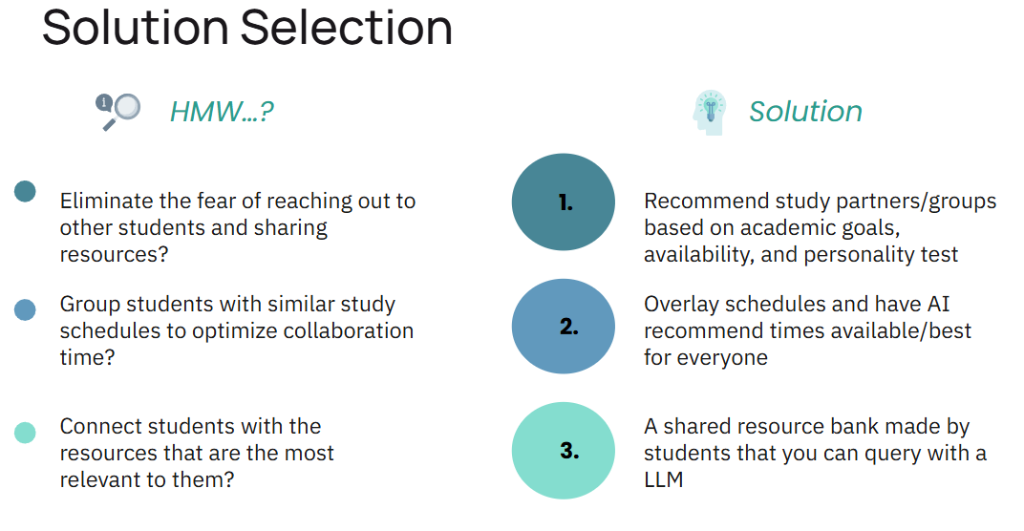

Figure 8 - HMW and solution selection side-by-side view

**Experience Prototypes**

| ***Solution*** | ***Assumption*** |
| --- | --- |
| Recommend study partners/groups based on academic goals, availability, and personality test | People are open to making a school profile and be matched to other students |
| Overlay schedules and have AI recommend times available/best for everyone | People know and can share their study availability in advance |
| A shared resource bank made by students that you can query with a LLM | People want to ask study app or resource questions to a LLM |

**Experience Prototype #1**

***Assumption*** - People are open to making a school profile and be matched to other students

**Description:** We created a questionnaire that asks about study habits, personality and class expectations to determine the “fit” between potential study partners

**Props:** We created a physical “profile worksheet” containing questions relevant to studying habits and characteristics. Discussions took place after completion.

**Participants & Relevance:** The participants were all Stanford students, mostly undergraduates under the engineering school. They were recruited through warm contacts.

**Method:** A person was asked to thoughtfully fill out the profile worksheet, and asked if they would be willing to form a study group with other participants, judging by their previously filled profiles.

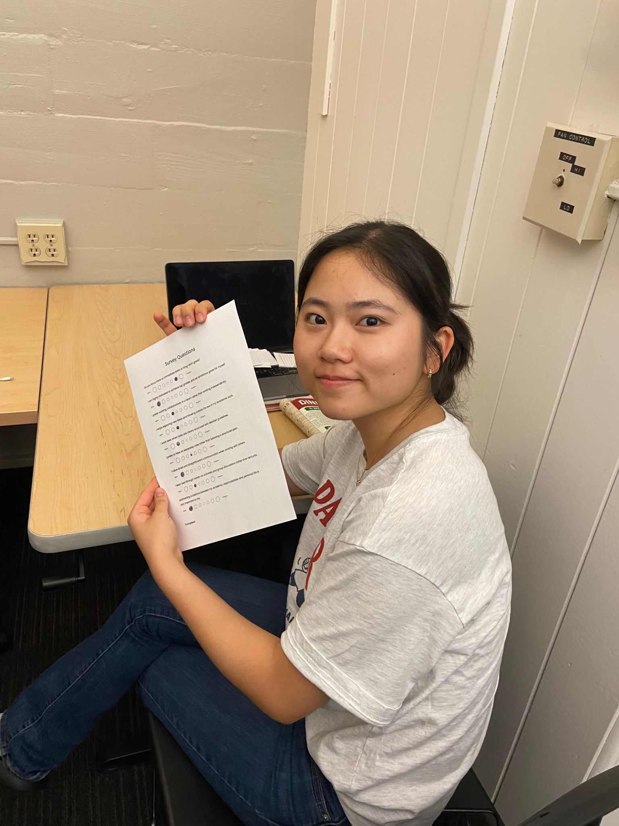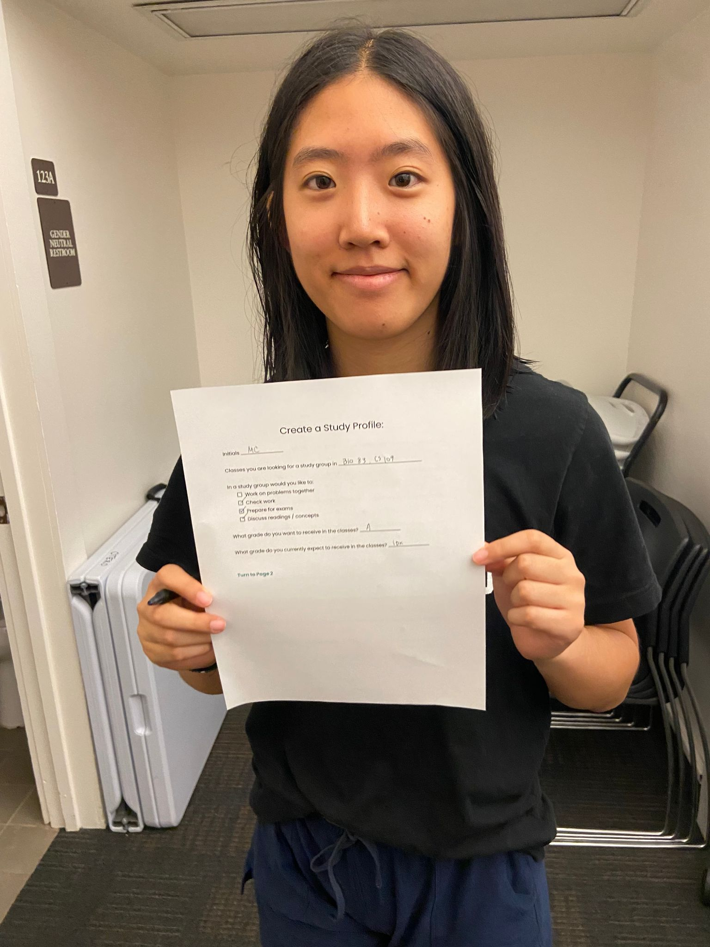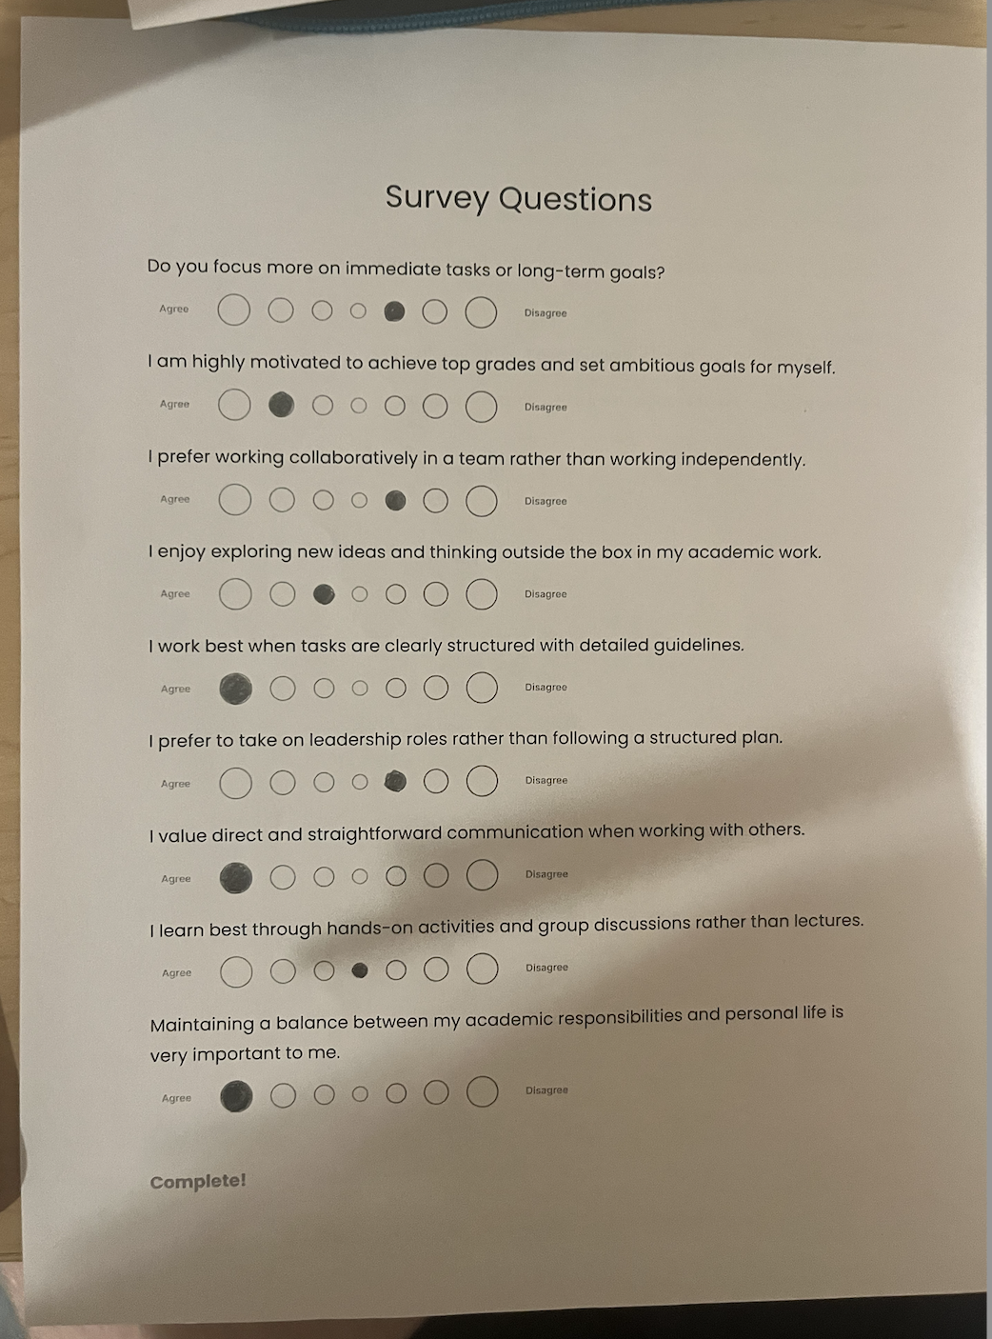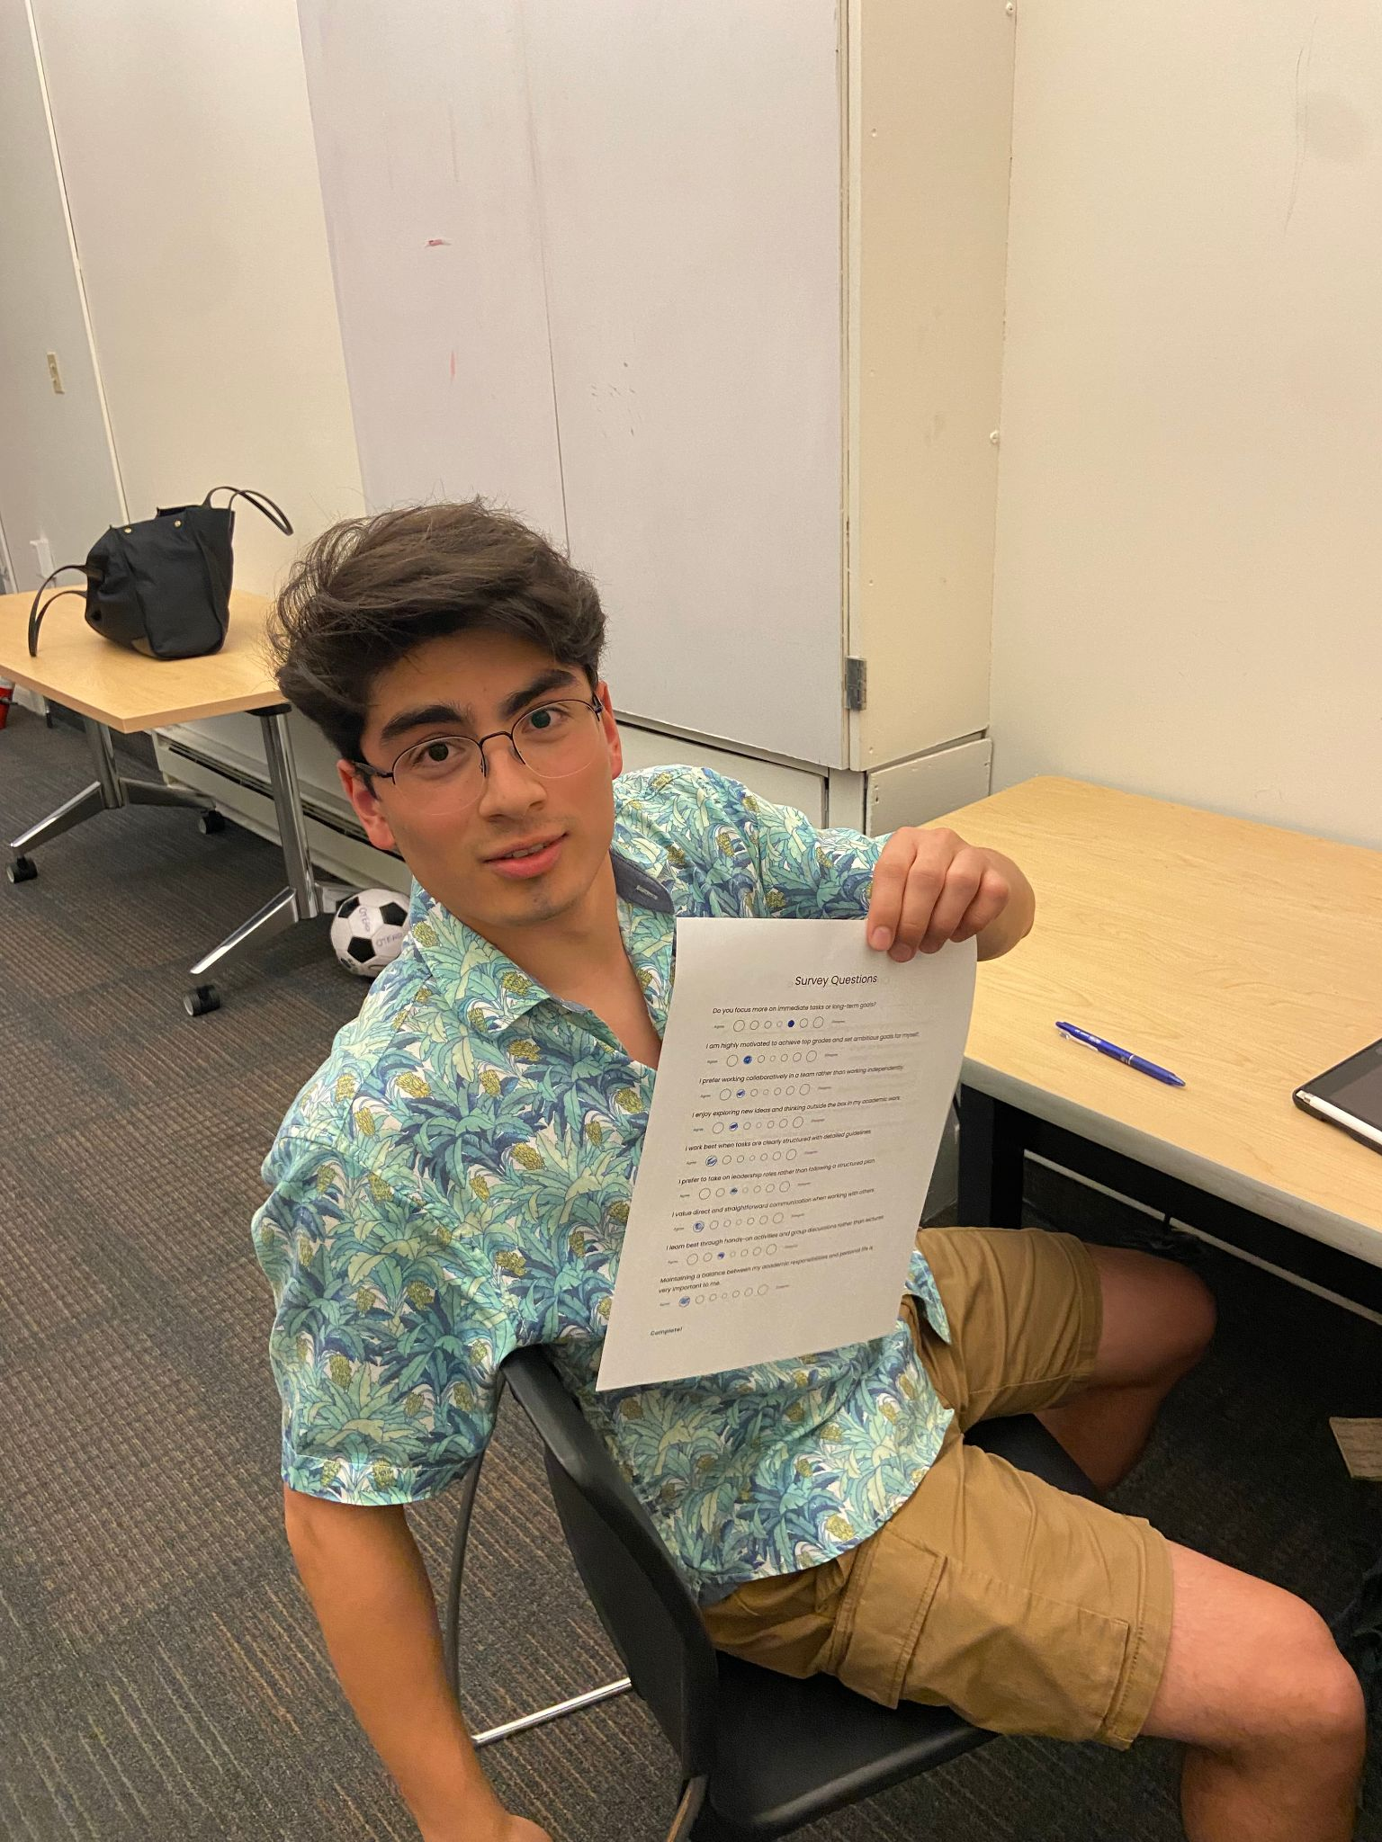

Figure 9 - Our first experience prototype and test participants

**What worked:** Participants said it was both easy to use and informative on a personal level. They appeared to enjoy answering the survey questions and expressed interest in finding study partners in multiple classes.

**What didn’t:** Participants noted that the lack of definitive scheduling questions may lead to scheduling conflicts in the future

**Assumption: Assumption validated**. Students are open to, and more than happy to, create profiles for themselves and match with those whose studying habits or personalities matched their own.

**Experience Prototype #2**

***Assumption*** *-* People know and can share their study availability in advance

**Description:** We created a schedule where users can fill in the times that they *would* like to study

**Props:** We created a physical “schedule worksheet” containing questions relevant to scheduling availability. Discussions took place after completion.

**Participants & Relevance:** The participants were all Stanford students, mostly undergraduates under the engineering school. They were recruited through warm contacts.

**Method:** A person was asked to thoughtfully fill out the scheduling worksheet, and asked if they would be willing to form a study group with other participants, judging by their previously filled schedules.

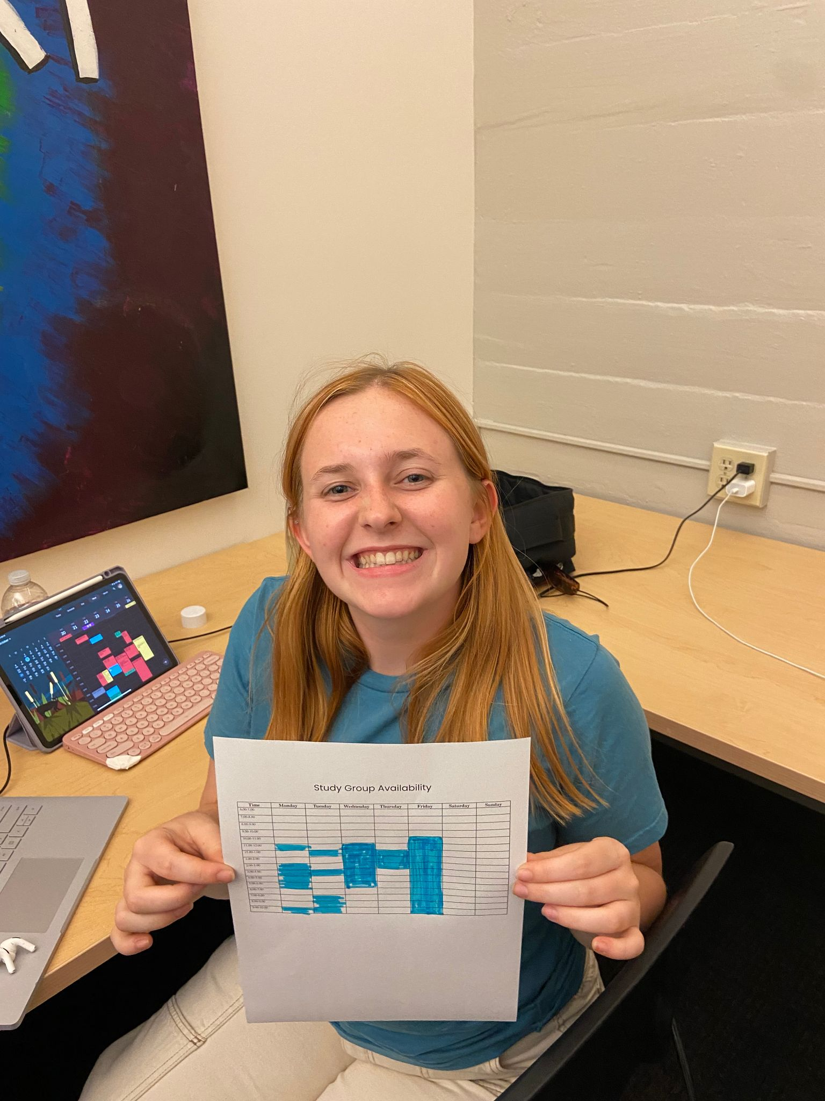

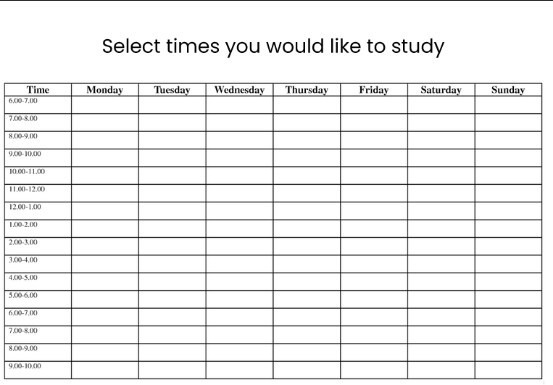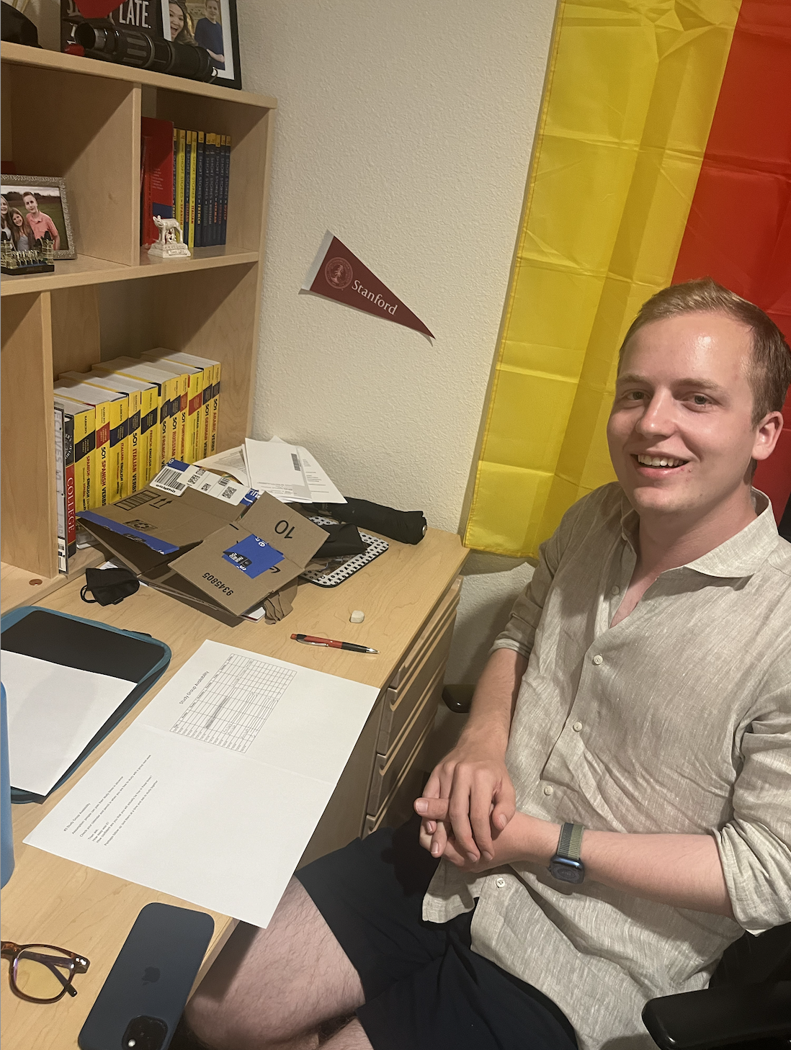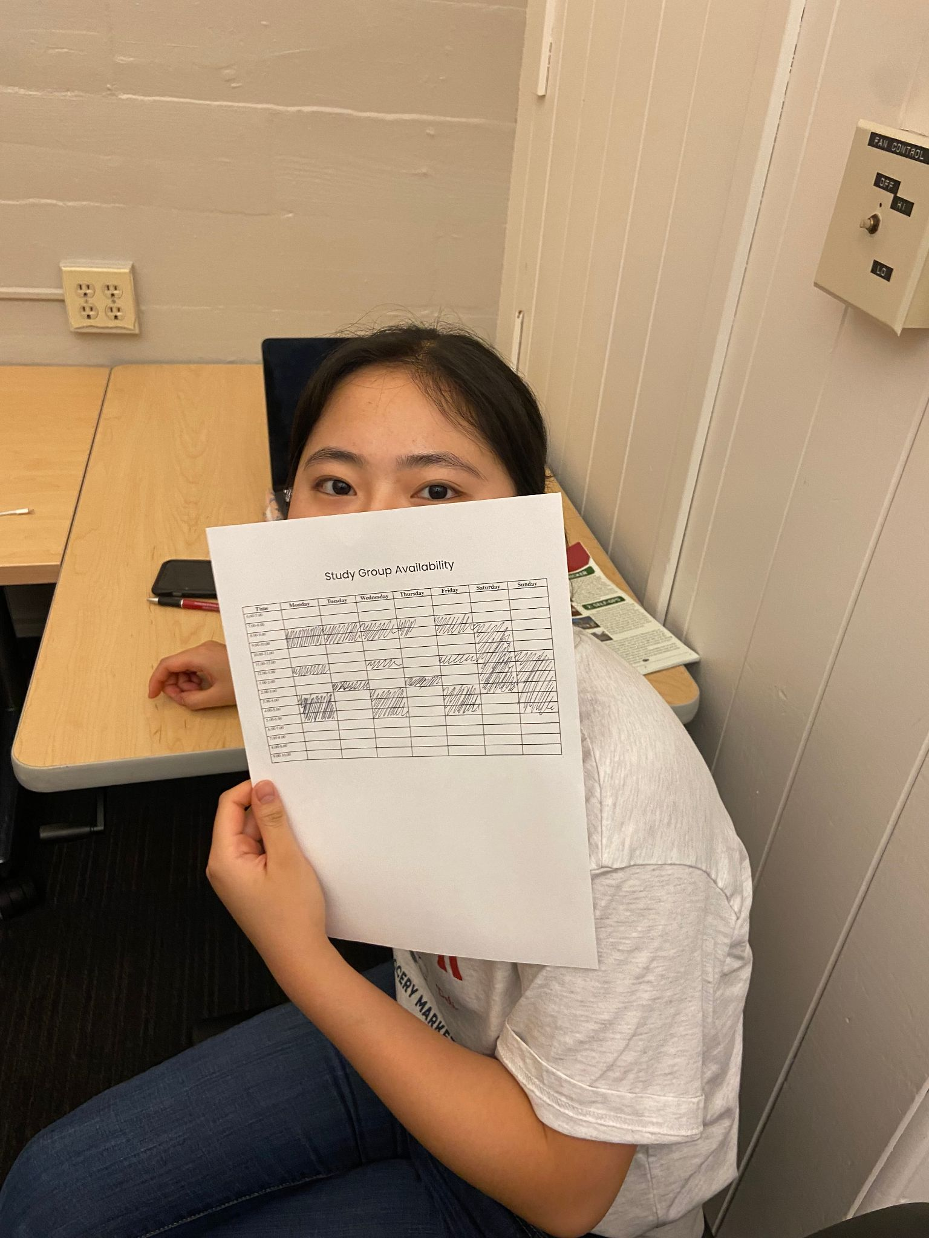

Figure 10 - Our second experience prototype and test participants

**What worked:** Participants said it was easy to fill and compare, yet insufficient in giving enough information about the potential study partner to be convincing

**What didn’t:** Participants noted that schedules vary a lot throughout the quarter and their availabilities could change unpredictably. In addition, they expressed unpleasant feelings about planning logistics

**Assumption: Assumption somewhat validated.** Stanford students can plan their schedules beforehand, but are hesitant to make long-term commitments, and find the process unappealing.

**Experience Prototype #3**

***Assumption*** *-* People want to ask study app or resource questions to a LLM

**Description:** We created an “LLM” that **takes in** user questions related to school/career and returns outlined steps reaching said goals or relevant resources

**Props:** Our prototype was a text message thread that acts as an “LLM” with people ready to respond after user sends questions. Discussion took place after the exercise.

**Participants & Relevance:** The participant was a Stanford student interested in EE, with industry background. He was recruited as a friend, and was particularly relevant because he is back after a leave and is trying to get study help and find resources.

**Method:** The participant was asked to text the LLM whenever he had questions on classes, studying, or resources over a 3-hour period. He was on standby to reply as an LLM, using knowledge of Stanford & EE.

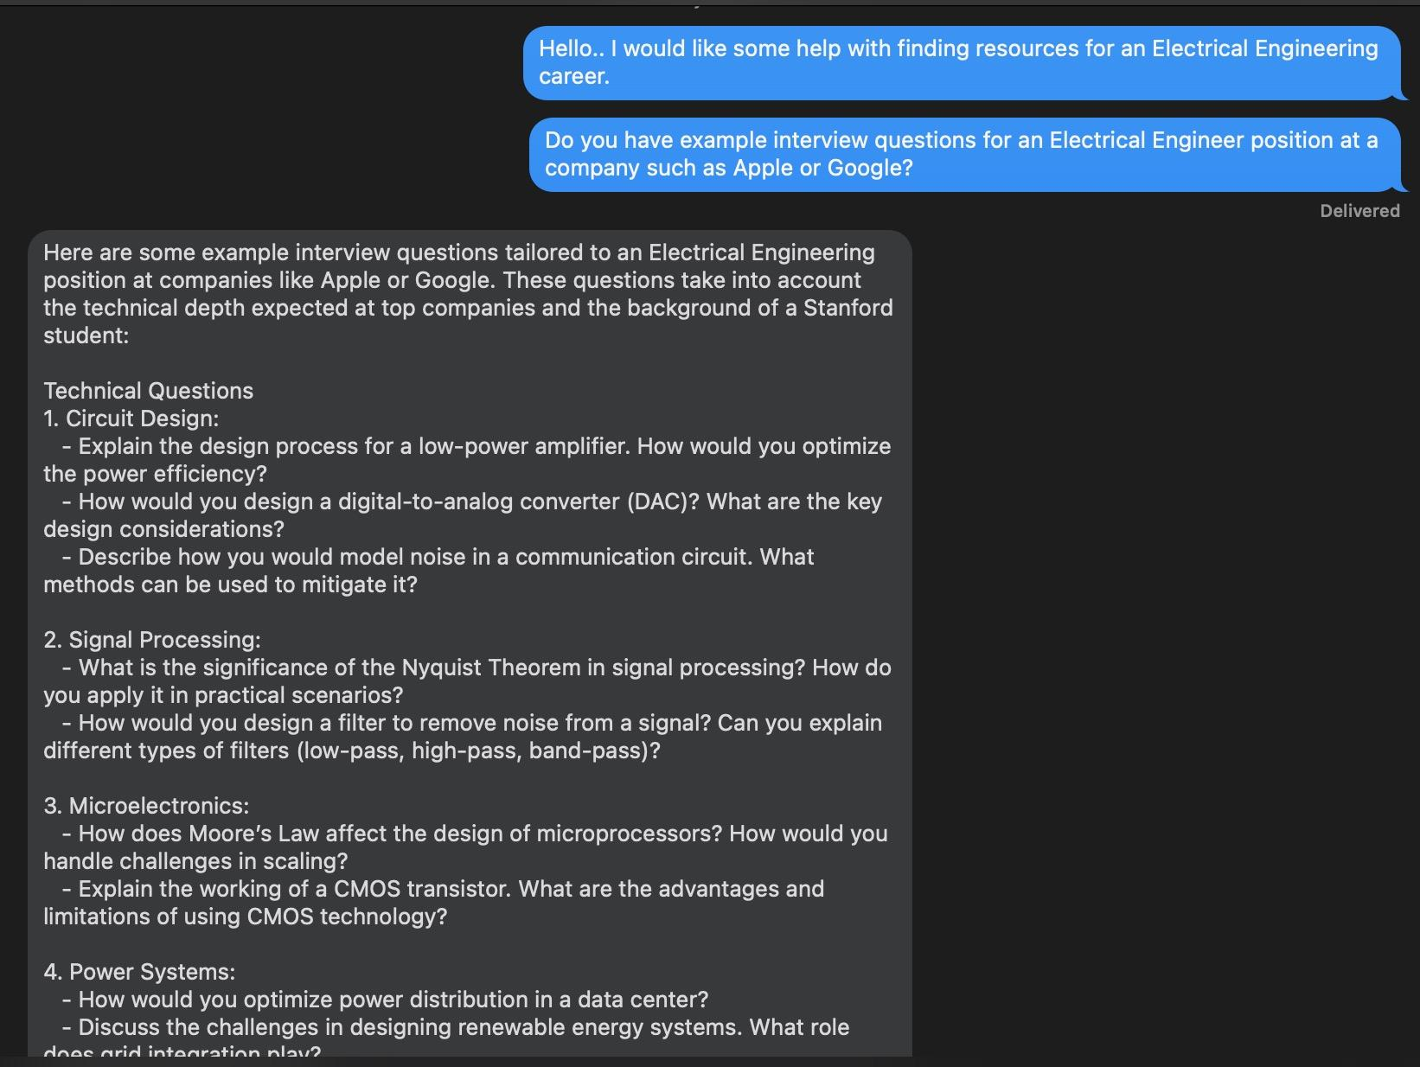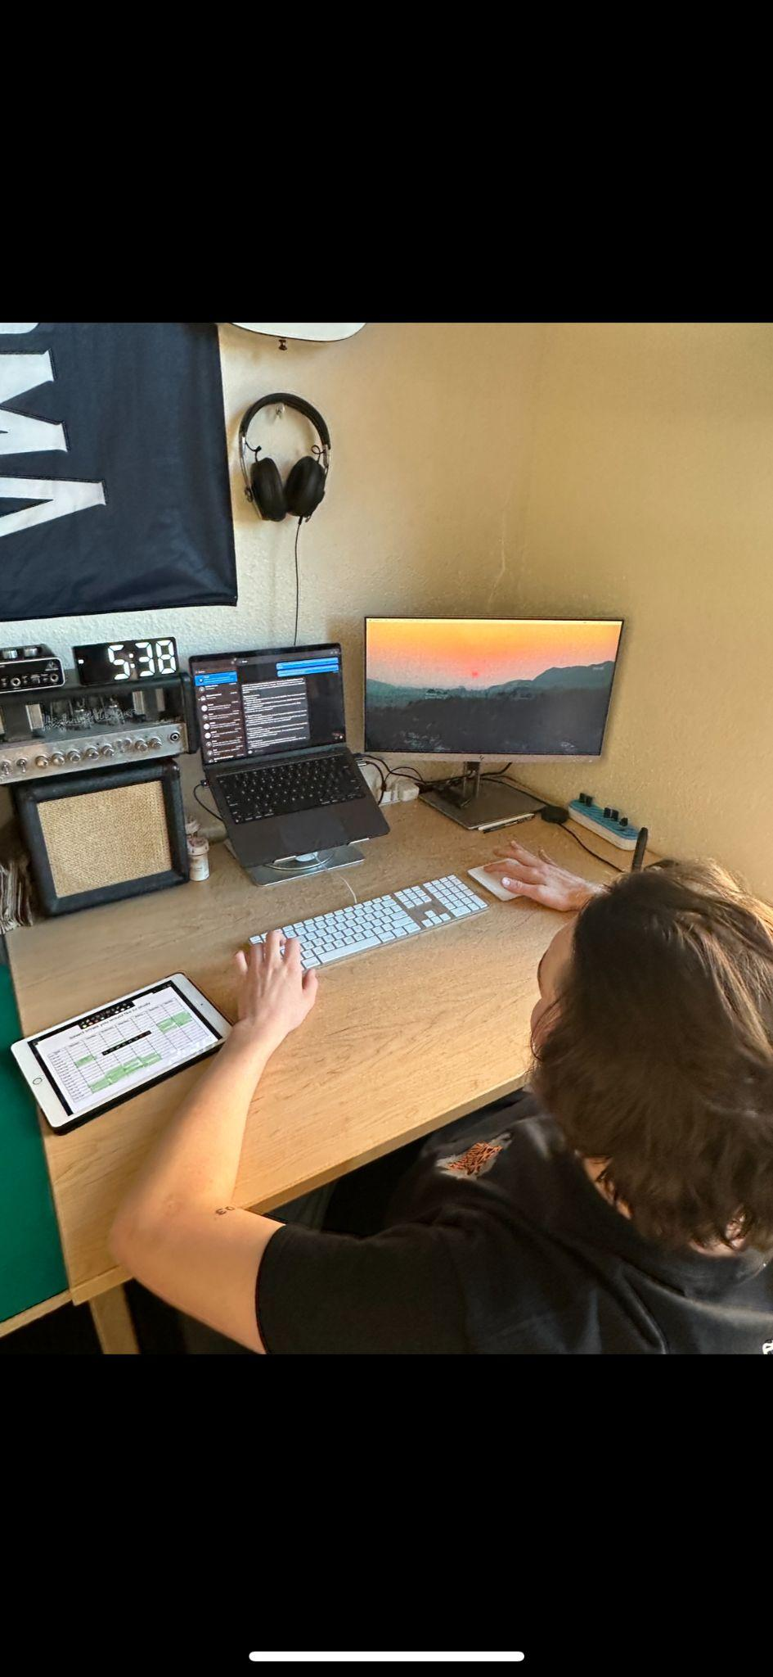

Figure 11 - Our third experience prototype and test participant

**What worked:** Our participant appreciated how easy it was to use and the range of functionality (how to access X resource? How to best study for [class]? What classes/ actions can I take to break into Y career)?

**What didn’t:** 1) Scraping for very niche or protected information is difficult, could lead to generic or unhelpful answers. 2) Training on school-specific information has many barriers

**Assumption: Validated,** users find LLMs useful for asking a variety of questions and tend to do so without hesitation (less confrontational than asking others)